Data Analysis Report: Final Draft

Vu Dinh Thien
220170
Fulbright University Vietnam
SOCI311_Spring2024_S01: Advanced Quantitative Research
Prof. Ethan Christopher Brown
April 20, 2024

Revision memo
- A summary of the feedback.
For the dataset and background, I need to clarify the research motivation and bring it to the front. Also, explain why the focus is only on the High and Very High HDI groups. Besides, I should consider deleting the HDI group variable from the regression, while keeping it in the descriptive statistics. Regarding the report, it is not quite written out as a unified narrative report. The opening is abrupt and confusing, and the narrative is not cohesive. Some other issues: causal language, e.g., affect, lead, etc., data file name. Lastly, there is a suggestion adding in the slopes’ interpretation, i.e. each variable's predicted impact on GII and their relative magnitude in the discussion/conclusion.
- What have changed in the draft to address the feedback and any other changes.
Firstly, I changed the content and arrangement to unify the report’s narratives. Then, I edited the opening to easier understand the report’s aims, data choice, etc. Secondly, I edited the code for the regression and interpretation to exclude the HDI.group variable from the beginning. Thirdly, I added the discussion part to summarize the findings and my implications before drawing any conclusion (and editing the conclusion as well). Lastly, I formatted all information on the files and adjusted the citation to the APA styles.
- Any comments about the revision process.
I learned a lot in this learn-and-relearn process. From initiating research by myself to finishing it, I got comments and feedback that I could find myself on what is good, what needs correction, and what should be cautious. In particular, conducting research is easy, but unifying and interpreting the results is much more challenging. Thanks to the constant support from the Professor, I am improving these.

Research motivation
Gender inequality is considered one of the hottest topics of contemporary human society. The efforts to build a more equal environment are one of the key missions of every country. The Gender Inequality Index (GII), covering reproductive health, empowerment, and the labor market, is the measurement to evaluate the country’s gender status. It is believed that the countries with higher human development and more equal economic distribution should have more parity in society for males and females. According to David and Max (2023), gender inequality can be addressed through poverty reduction (Gini coefficient) and education (HDI).
Nevertheless, some critiques that compare HDI’s involvement in the country's development among countries with high HDI values (greater than 0.700) seem meaningless and redundant. This raises a concern on its effects among these countries to the lower gender inequality. Are the highly human-developed countries likely to have low gender inequality?
The data used is extracted from the Data of the United Nations Development Programme (https://hdr.undp.org/data-center/documentation-and-downloads.) The countries that belong to the first two highest HDI groups – the Very High and the High are chosen along with their economic distribution status to assess whether they have general gender equality. This choice is based on the above reasons. However, there is a missing statistic in the data assessing how the HDI and economic inequality issues correlate with the GII – the current measurement of Gender Inequality.
Overall, this study will test how much the effects of HDI and Gini coefficient on the level of GII.
Research question

How do the Human Development Index (HDI) and the Gini coefficient values predict the Gender Inequality Index (GII) in two groups: Very high human development and High human development countries?

Report’s structure
The countries that belong to the first two highest HDI groups – the Very High and the High are chosen along with their economic distribution status to assess whether they have general gender equality. The study will analyze the descriptive statistics between the variables with the comparison between the High and Very High group’s data characteristics. Then, the regression predicting the GII by HDI and Gini coefficient is initiated. By running the multiple variables linear regression, I can find the intercept, the coefficient number for each variable, and the error values to see the effects of each explaining variable on the GII in every country. Then, I can also use the adjusted R-squared value to assess the overall precision of the response variable predicted by predictor variables. Beyond that, I will use ANOVA to test the significance of the model by comparing it with the predicting model of constant numbers.

Characteristics of the model
The data table is available in this link document: Data. There are six columns: The HDI rank is used as an identity number corresponding with the Country’s name; the group of HDI is the categorical variable to label the group of countries having very high HDI, and another having high HDI. The rest are numerous variables: the Gender Inequality Index (GII) value, the Human Development Index (HDI) value, and the percentage of Gini coefficient value.
Data source description:
This data is taken from https://hdr.undp.org/data-center/documentation-and-downloads, in Tables 1, 3, and 5. Data collected are the GII value (response variable) and two predictor/explain variables: the HDI value and the country’s Gini coefficient value. This research data is limited to countries in the Very High and High Human Development groups.
Variables explanation: According to Human Development Report and Our World in Data:
- Gender Inequality Index (GII): composite measure, reflecting inequality in achievements between women and men in three dimensions: reproductive health, empowerment, and the labor market. It ranges from 0, where women and men fare equally, to 1, where one gender fares as poorly as possible in all measured dimensions.
- The Human Development Index (HDI): a summary measure of average achievement in key dimensions of human development: a long and healthy life, being knowledgeable, and having a decent standard of living, also ranges from 0 for the lowest to 1 for the highest.
- The Very High/High HDI category: Separate two groups of HDI levels: 0.700–0.799 for High human development and 0.800 (or greater) for Very High.
- The Gini coefficient (Gini): measures inequality on a scale from 0 to 1, where higher values indicate higher inequality. In this data, we use the percentage scale, so 0 indicates perfect equality and 100 indicates perfect inequality.

Describing data
Data descriptive analysis
We will see each variable’s distribution in two groups of Very High and High HDI countries:
GII:
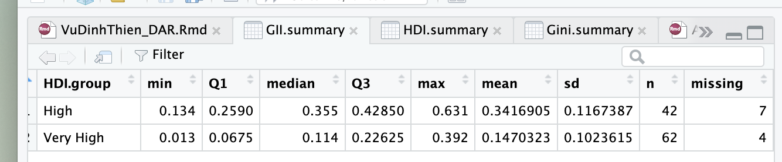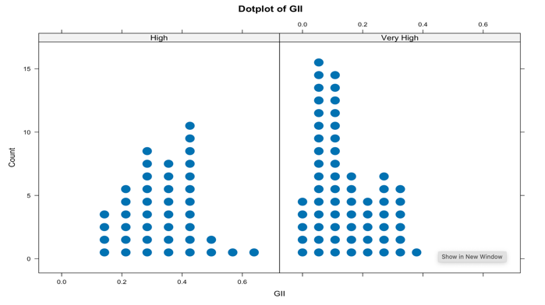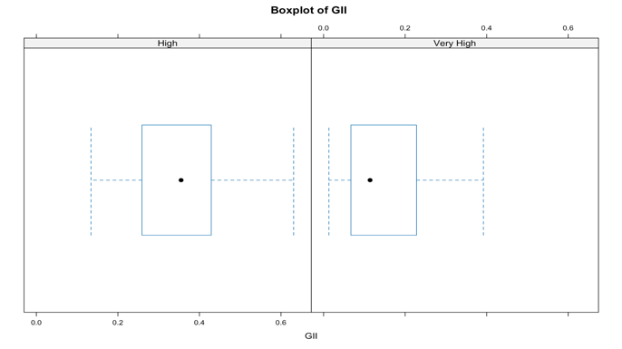
Generally, most countries among the two groups have no greater than 0.5 points of GII. In addition, with the mean compellingly low (only 0.34 and 0.14) and the standard deviation only about 0.1, these two groups of high HDI value compellingly have low gender inequality.
Comparing the two groups, the Very High group tends to have a smaller GII distribution in both the mean and standard deviation of the data. Thus, the group with higher HDI might have better parity between males and females.
HDI:
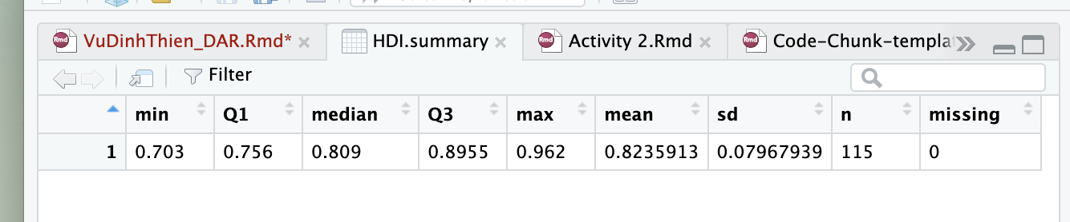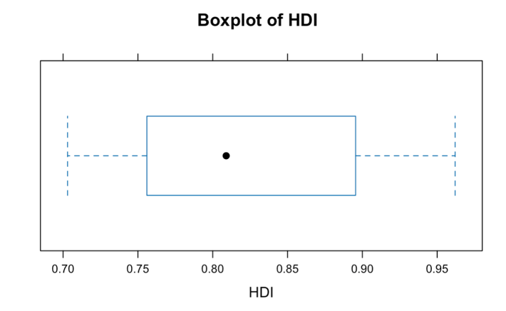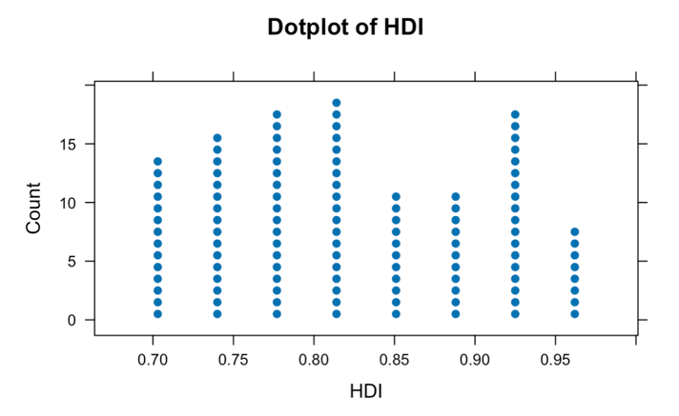
This seems meaningless to compare the distribution of HDI between two groups since it is already stated in their group’s name. Instead, we will consider the overall distribution of HDI. The mean and the standard deviation are 0.82 and 0.08, respectively. Looking at a graph, it is quite equal spreading distribution overall.
Gini:
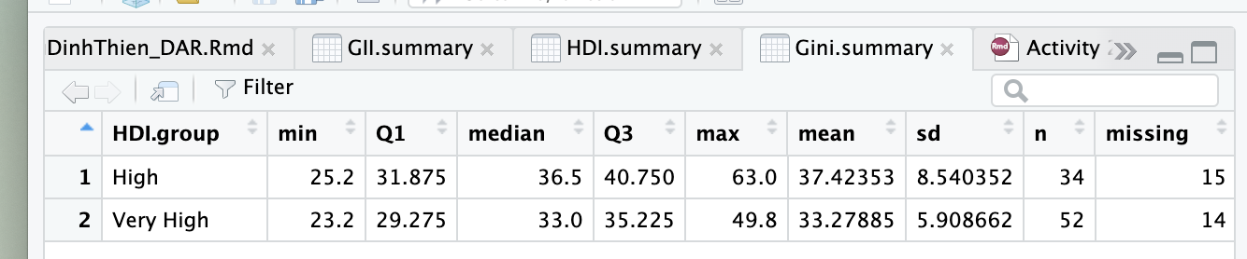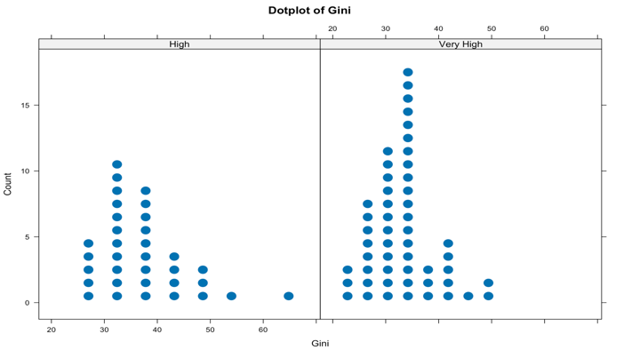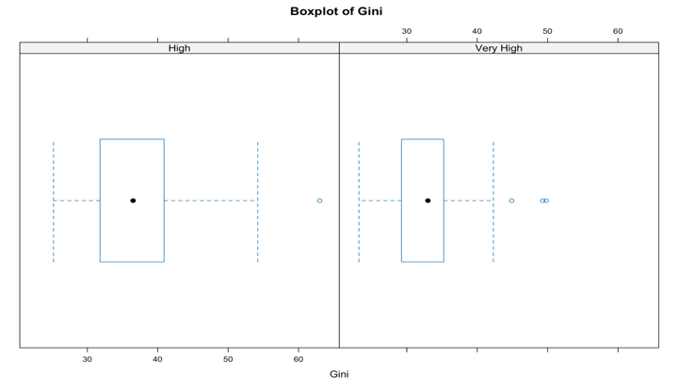
Most countries among the two groups have no greater than 0.5 points of the Gini coefficient. Besides, the shape of each group is similar to the normal bell-shaped distribution. It tells us that the Gini coefficient has a normal distribution with some neglectable skewness, or the inequality in wealth is a normal distribution among the two groups.
While the Very High group has a slightly lower mean of Gini compared to the High, the standard deviation is sharply different between them (8.54 > 5.9). This means that the group has lower HDI tends to have a more varied inequality context. Notably, there are some outliers indicating the high Gini coefficient in the very high HDI countries.
Two-way relationships
GII and Gini

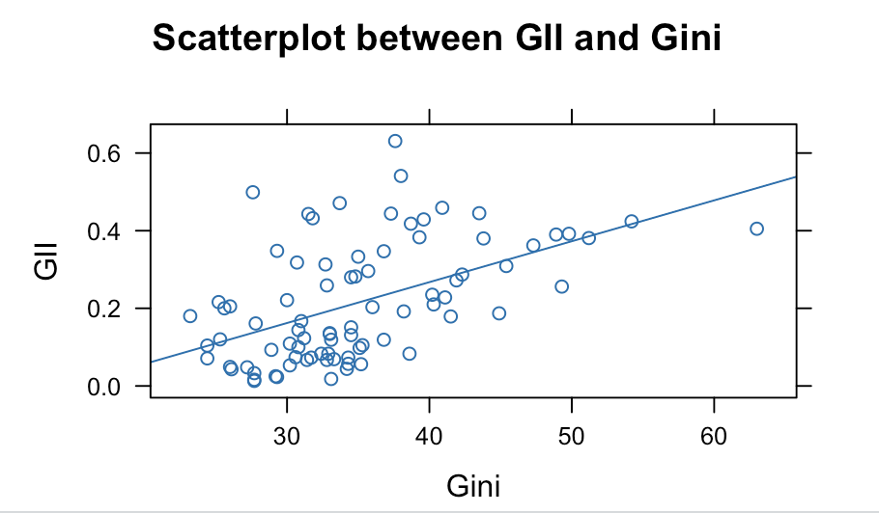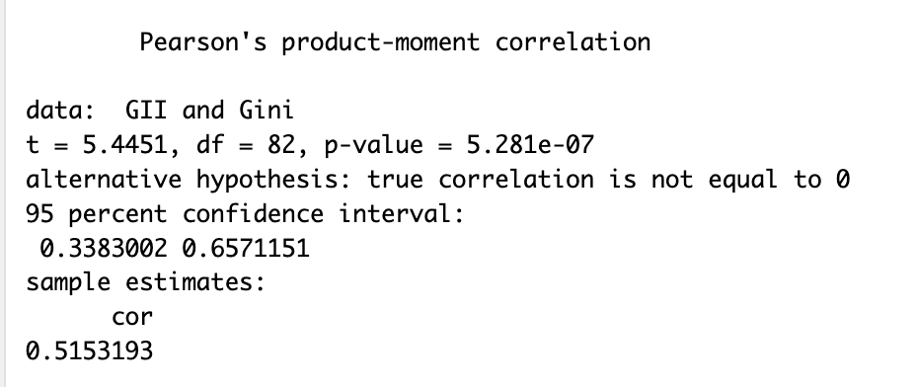
There is a positive correlation between GII and Gini that an increase in one unit of Gini will lead to a 0.52 unit increase in GII. It means that the country has higher Gini value, i.e., more income inequality is likely to have the higher gender inequality rate. Put in another way, this inequality has some impact on another inequality. With a very small p-value, we can reject the hypothesis of no correlation between GII and Gini.
GII and HDI
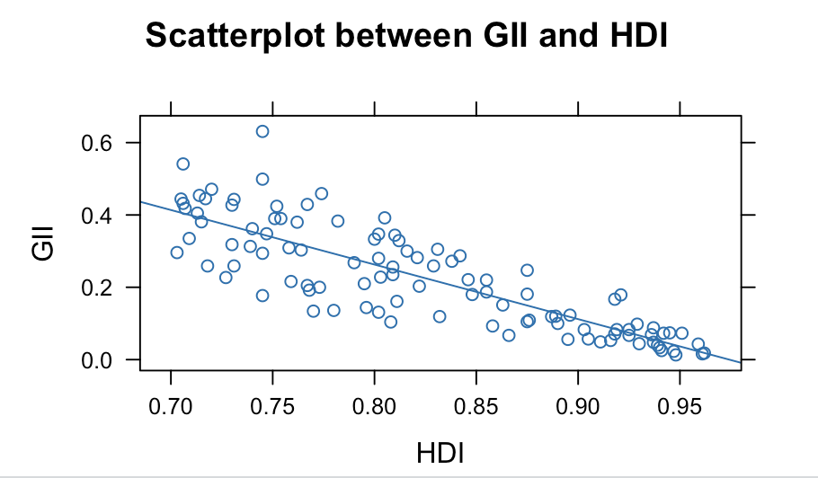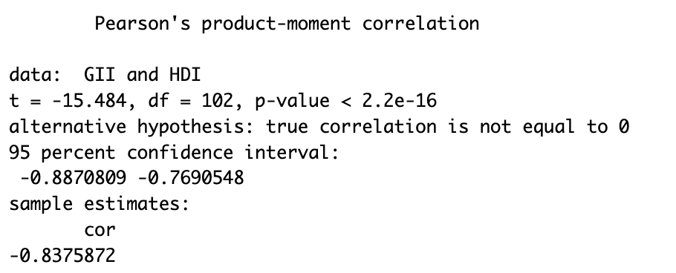
There is a strong negative correlation between GII and HDI that an increase in one unit of HDI will lead to 0.84 unit decreased of GII. It means that the country achieving higher HDI value has a strong motivation to decrease the gender inequality rate. With a very small p-value, we can reject the hypothesis of no correlation between GII and HDI.
Gini and HDI
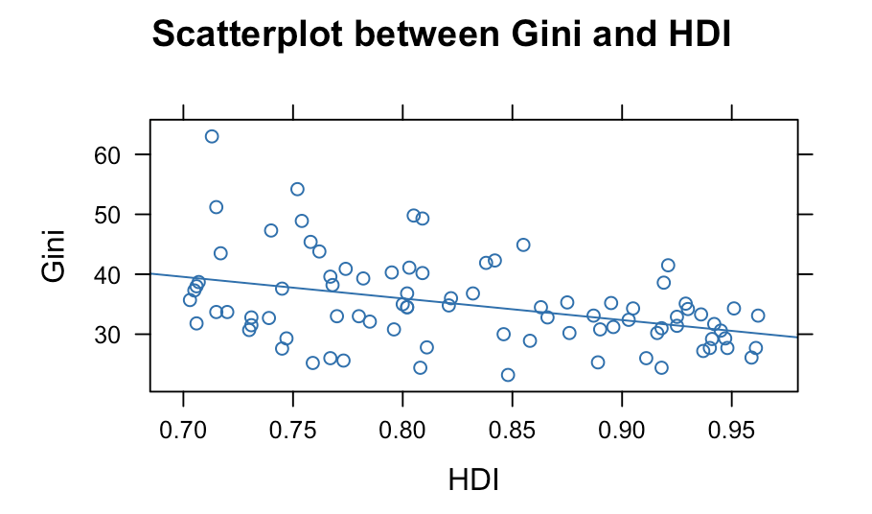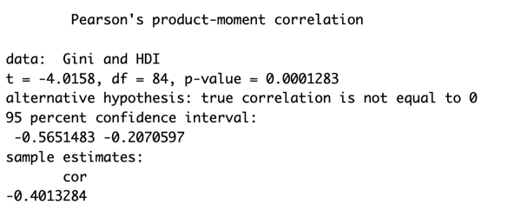
There is a negative correlation between Gini and HDI that an increase in one unit of HDI will lead to a 0.40 unit decrease in Gini. It means that the country achieving a higher HDI value also decreases the population’s income inequality. With a small p-value, we can reject the hypothesis of no correlation between Gini and HDI.
Scatterplot Matrix
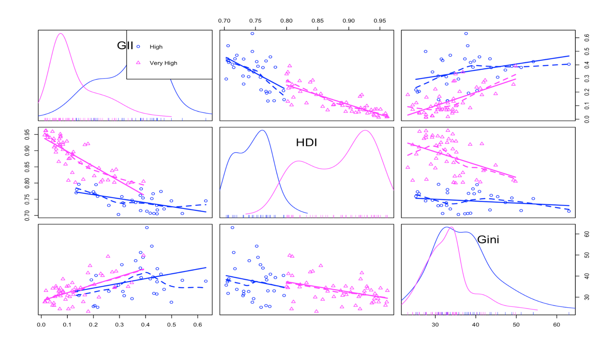

Here is the scatterplot matrix showing the relationship of the above pairs, indicated by two groups: Circle for High and triangle for Very High. We will only focus on graphs #1; #5; and #9 since they describe the relationship between each variable's relationship with the HDI.group variable only. The other graphs describing the relationships of three variables are beyond what we are observing and should be skipped for now.

Observing the GII and HDI graphs, we can see that the Very High group has higher HDI and lower GII values. While the Gini graph has a similar left path between the two groups, the right path shows a sharp difference between the High and Very High groups, indicating a higher Gini in the High group. This finding is consistent with what we observed from the single scatterplot.

Running/evaluating the linear model
Model explanation
GII.mod: The linear model used to answer the research question:
GII = a + b*HDI + c*Gini + error
The HDI, Gini, and GII are explained above. Explaining variables are HDI and Gini; responding variable is GII.
The multicollinearity test proves the independence of the three variables (all smaller than 5):
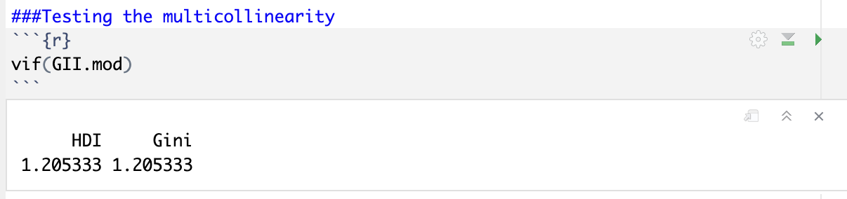
The other modes are used as part of the evaluation:
- GII.mod.reduced: Testing the prediction of the constant number.
- model1nona: GII.mod with N/A observations excluded.
- model2nona: GII.mod.reduced with N/A observations excluded.
(Comparing the model summary, this dropping action's effect can be neglectable.)
Result
The main model: GII = 1.271 – 1.440*HDI + 0.004*Gini + error
Multiple R-squared is 0.7624 and Adjusted R-squared is 0.7566, reasonably high correlation showed in the model.
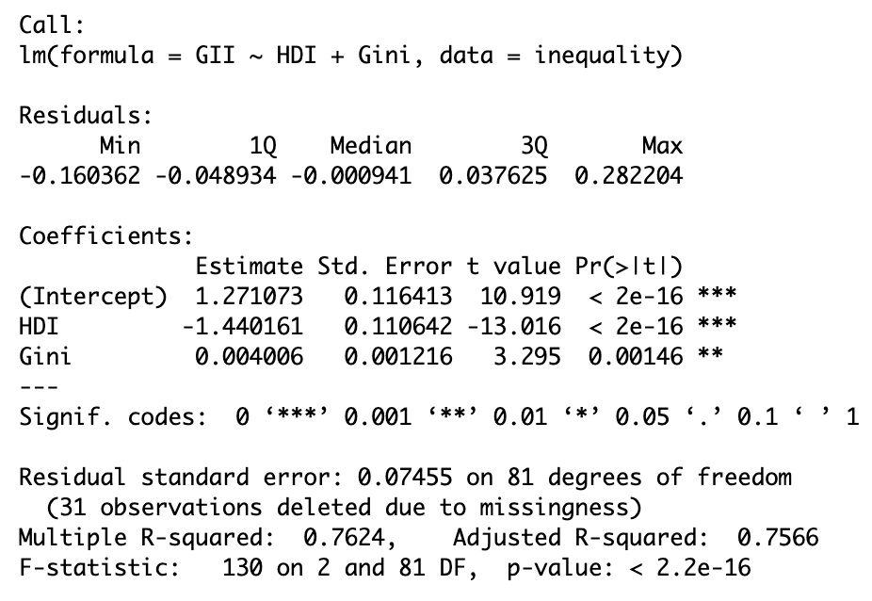
The intercept, HDI, and Gini value reasonably explain the GII in the model since their p-value is low.
The ANOVA test between the model1nona and model2nona model proves the effective impact of adding explaining variables into the model, i.e., HDI and Gini values can influence the change in GII.
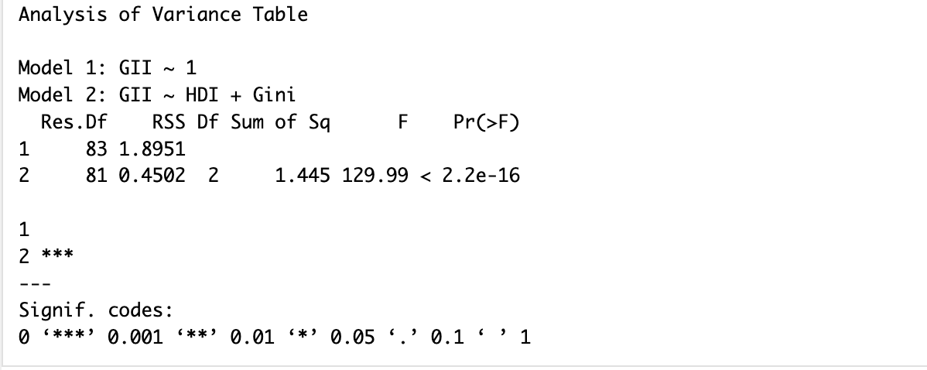
Overall, we have the linear model: GII = 1.271 – 1.440*HDI + 0.004*Gini + error
Evaluate the regression assumptions
- Linearity: The model meets this assumption because the scatterplot seems to follow a single linear trend.
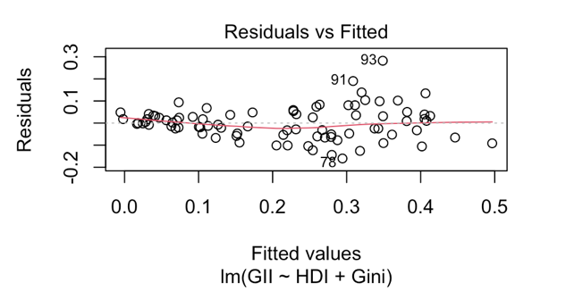
- Equal spread: Looking at a graph again, the data fairly spreads covering the whole x line without any too extreme points. However, the data seems clustered on the left of the data while spreading out on the right side. Thus, the equal spread looks not so satisfied.

- Independence (Independent Observation): HDI, GII, and Gini values are independent because they are unique measurements for only citizens of a country. Although there are interactions from one country to another, this effect often has a lag. Here, we use the same year for every variable; so, the interference across the country is minimized.

- Normality: The data almost fits the Q-Q line. Therefore, the normality assumption is also satisfied.
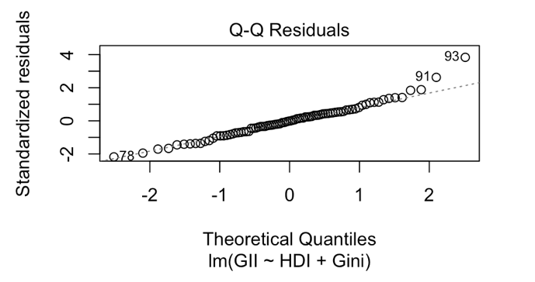

- Randomness: The sample data is chosen from the two top HDI groups of countries. Hence, there is nothing randomized.
Discussion
The descriptive data with scatterplot between each pair of variables and the matrix showed that there is a negative correlation between GII and the HDI while a positive between GII and Gini coefficient. These findings strengthen the hypothesis that the country with higher human development and less unequal economic distribution is likely to have lower gender inequality. Another finding is that the High group has both the GII and Gini seemingly higher than the Very High group, which is consistent with each pair’s correlation.
The regression shows the effective prediction of both HDI and Gini coefficient to the GII’s value. HDI’s negative slope of -1.440 shows that the increase in one unit of human development predicts a 1.44 decrease in gender inequality. Although Gini has a low correlation (0.004), its value is a percentage, i.e., 100 times larger than the other two values using a zero-to-one scale. Thus, in this correlation, one unit increase in income distribution predicts a (0.004 x 100 = 0.4) increase in gender inequality. These variables predict 76.24% of the gender inequality. Thus, human development and economic distribution have a strong correlation with the gender parity issue in highly human-developed countries.
Conclusion
With the high R-squared regression, the very low p-value, and the LINE assumption satisfaction (except the E-equal spread), we can conclude that there is a strong correlation between the Human Development Index (HDI) and the Gini coefficient values on the Gender Inequality Index (GII) in two groups of High and Very High human development countries. Among these countries, the population’s higher development and more equal share among citizens predict higher efforts to reduce gender inequality, resulting in a lower GII in that country.
While this study is quite persuasive in internal validity and reliability, it lacks external validity. All the data was collected from the Very High and High HDI countries. Thus, this study is exclusively applicable to the countries it covers. Moreover, although this study highlights the high correlation between explaining variables and predicting variables, there are still many more variables in human society, e.g., political status, natural disasters, countries eligible/excluded from observing groups, etc. that might considerably affect this model at another point in time. Therefore, this study needs to be tested in another timeframe and with a randomized group of countries.

References
United Nations. (n.d.). Documentation and downloads. Human Development Reports. https://hdr.undp.org/data-center/documentation-and-downloads
United Nations. (n.d.-b). Gender Inequality Index. Human Development Reports.
https://hdr.undp.org/data-center/thematic-composite-indices/gender-inequality-index#/indicies/GII
United Nations. (n.d.-c). Human Development Index. Human Development Reports.
https://hdr.undp.org/data-center/human-development-index#/indicies/HDI
Mandegar, D., & Olsson, M. (2023, July 10). Examining the Relationships between GII, HDI, Gini, and GDP per capita -A Comparative Analysis of Undeveloped and Developed Countries (1990-2021). https://hdl.handle.net/2077/77754
Hasell, J., & Roser, M. (2023, December 28). Measuring inequality: What is the Gini coefficient? Our World in Data. https://ourworldindata.org/what-is-the-gini-coefficient

